Adding Your Photo in Blackboard Collaborate Ultra
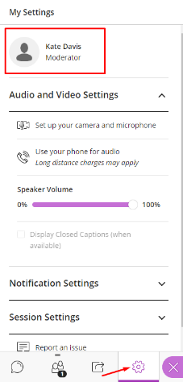
- To add a default photo in Collaborate enter any Blackboard Collaborate Ultra ‘Course Room’.
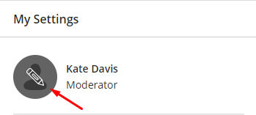
- Expand the side panel inside of the room and click on the gear icon to access your ‘My Settings’.
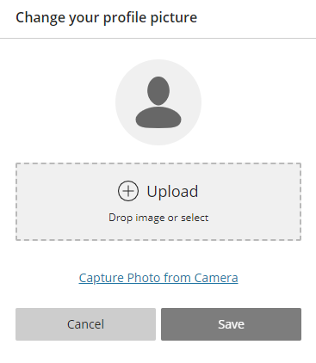
- At the top of the ‘My Settings’ menu you will see your name and an icon with the outline of a person. If you hover over the person icon a pencil will appear, and if you click on it you will be taken to a menu to upload a new profile picture.

